
Patrick J. McCarty,
Adjunct Professor, The Catholic University of America Columbus School of Law and Georgetown University Law Center, and Principal and Founder of McCarty Financial, LLC

Patrick J. McCarty the Principal and Founder of McCarty Financial, LLC.
Mr. McCarty is a seasoned financial services attorney with 35 years experience in banking, securities and commodities law. Mr. McCarty’s consulting practice focuses on cutting edge policy and regulatory issues related to commodities, swaps, fintech services and digital asset products. Mr. McCarty has significant senior staff legal experience with the US Federal Financial Regulators (CFTC, SEC and Banking) as well as legislative experience on Capitol Hill during both Dodd Frank Act and the Gramm-Leach-Bliley Act. Mr. McCarty provides sophisticated legislative and regulatory advice to financial services firms engaged in commodities, swaps, fintech services and digital asset products.
Mr. McCarty is an adjunct law professor at both Georgetown University Law Center, where he teaches a Seminar on Cryptocurrencies (2018 to present), and Catholic University of America Columbus School of Law, where he coteaches a Class on Derivatives (2011 to present) as well as a teaching a Seminar on Cryptocurrencies (2022 to present). Mr. McCarty is admitted to practice law in Virginia.

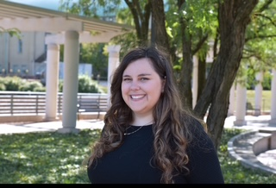
Audrey Anderle
3L, The Catholic University Law School

Audrey is currently a 3L at the Catholic University Law School where she is a part of the Securities Law Certificate Program. She is also the Vice President of the Securities Law Student Association, Vice President of the Democratic Law Student Association, Associate Editor of The Catholic University Law Review, and a Dean’s Fellow. During her time at law school she has interned at the Investment Company Institute, Securities and Exchange Commission, Enforcement Division, and Ruddy Gregory, PLLC.
Prior to law school Audrey got her B.A. in Policy and Government and Economics at the University of Maryland in 2019. She then worked as an Office Assistant at the Managed Funds Association before being promoted to assisting their international affairs team after 9 months. From there she went to K&L Gates where she worked as a Policy Governmental Affairs Assistant supporting the Tax and Financial Services Policy subgroups for 3 years.

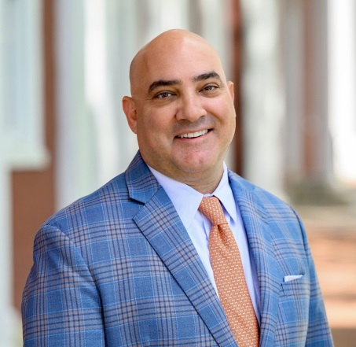
Kevin Batteh
Partner and General Counsel

Kevin Batteh, a partner of Delta Strategy Group, is a seasoned financial services lawyer with over 25 years of futures and swaps market regulatory experience. Kevin joined Delta Strategy Group in August 2014 and assists clients across a range of areas including regulatory compliance, enforcement, and policy issues related to domestic and international derivatives and energy markets. Kevin also acts as a senior advisor to a number exchanges, traders and a host of blockchain and digital currency technology companies. Kevin and Delta Strategy Group were the first multi-client lobbying firm to represent the digital asset industry before Congress starting in 2014.
Kevin began his career as a complex litigation associate at a Fortune 100 law firm. In 2003, after five years of private practice, he joined the CFTC as a trial attorney in the Division of Enforcement where he investigated and prosecuted cases of fraud and market manipulation in Federal District Courts across the country. Kevin left the CFTC in 2008 to take a senior lawyer role with the UK Financial Services Authority (now Financial Conduct Authority) in the Division of Enforcement where he investigated cases of securities and derivatives market abuse, market manipulation, and insider trading.
​Kevin returned to the CFTC in 2010 and served as a chief trial attorney responsible for leading a team of lawyers and investigators in the US Dollar LIBOR rate manipulation cases that ultimately resulted in billion-dollar settlements. In 2011, Kevin transitioned from Enforcement to serve as counsel to CFTC Commissioner Jill Sommers, where he provided legal and policy advice concerning the CFTC’s Dodd-Frank rulemaking, regulation of futures and swaps, enforcement matters, and foreign jurisdictions’ regulatory policy and legislation.
Immediately prior to joining Delta Strategy Group, Kevin served Senate Agriculture Committee Ranking Member Thad Cochran as special counsel and policy advisor for futures and derivatives, where he had responsibility for the confirmation of Commodity Futures Trading Commission (CFTC) Commissioner Nominees and CFTC reauthorization legislation. Kevin is admitted to practice law in Washington, D.C. and Virginia.


Stephen Humenik
Senior Vice President, Global Head of Capital Markets, and Head of Clearing, Crypto.com

Stephen Humenik is Senior Vice President, Global Head of Capital Markets and Head of Clearing at Crypto.com. As the Global Head of Capital Markets Legal at Crypto.com, Mr. Humenik leads the legal team as they execute Crypto.com’s global capital markets strategy by offering its customers a wide range of financial products. As Head of Clearing, Mr. Humenik lead the business and strategy of Crypto.com’s CFTC-regulated clearinghouse for derivatives.
Mr. Humenik began his career in the Division of the Enforcement at the CFTC, where he spent a combined eight years. While at the CFTC, Mr. Humenik also served as a Special Counsel & Policy Advisor to former Commissioner Scott O’Malia. Mr. Humenik then served as General Counsel and Chief Regulatory Officer of a CFTC-registered interest rate swap futures exchange. Mr. Humenik then entered private practice for nearly 10 years where he assisted clients that represent the entire derivatives market ecosystem, both in the U.S. and globally. Specifically, Mr. Humenik led the Futures and Derivatives Practice at Covington & Burling, LLP prior to joining K&L Gates, LLP as a Partner where he led their derivatives practice. Mr. Humenik is admitted to practice law in Washington, D.C., Illinois and Maryland (inactive).


Summer Mersinger
CEO, Blockchain Association

Summer Mersinger is CEO of Blockchain Association, where she leads advocacy efforts to advance digital asset innovation and policy in Washington. She previously served as a Commissioner of the Commodity Futures Trading Commission, nominated by President Biden and unanimously confirmed by the Senate. With over 20 years of experience in public policy and government affairs, Summer has held senior roles at the CFTC, on Capitol Hill as Chief of Staff to Senator John Thune, and in the private sector. Summer is admitted to practice law in Washington, D.C.

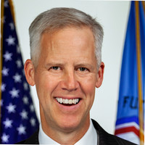
Kevin Webb
Senior Special Counsel, Detailee, U.S. Senate Committee on Agriculture, Nutrition, & Forestry, U.S. Commodity Futures Trading Commission

Kevin currently serves as Senior Special Counsel at the U.S. Senate Committee on Agriculture, Nutrition, and Forestry (Senate Ag). He holds that position as a detailee from the U.S. Commodity Futures Trading Commission (CFTC) where he has served for eighteen years. Prior to being detailed to Senate Ag, Kevin was detailed to the U.S. House of Representatives Committee on Agriculture (House Ag) and served as Chief of Staff to CFTC Commissioner Brian Quintenz, Special Counsel to CFTC Chairman Chris Giancarlo, Senior Special Counsel in the CFTC’s Office of International Affairs,, and Senior Trial Attorney in the CFTC’s Division of Enforcement. Before joining the CFTC, Kevin was a Trial Attorney in the Environment and Natural Resources Division of the U.S. Department of Justice and an Associate in the litigation departments of Goodwin Procter and Hunton and Williams. Kevin holds Juris Doctor and Bachelor of Science in Commerce degrees from Washington & Lee University. Kevin is admitted to practice law in Washington, D.C., Virginia (inactive), and Maryland (inactive).

